**WEEKLY ASSIGNMENT 1**

**Total Time: 2 Hrs**

**Total Marks: 100**

1. **Short Questions (Best of 10) (Total Marks: 10x2 = 20)**
2. **What are the main features of OOP?**

The main features of OOP are Polymorphism, encapsulation, inheritance and abstraction. It is dynamic in a way that allows a many object instances to be created from a single class.

1. **What is encapsulation, Explain with code example?**
2. **What is Polymorphism, explain with code example?**

Polymorphism is taking a function and overriding or changing it to do a different function

using System;

class Factory

{

public virtual void CreateVehicle()

{

//This is the default value

int vehicleValue = 0;

Console.WriteLine("Vehicle created");

Console.WriteLine("Vehicle value " + vehicleValue);

}

}

class Car : Factory

{ ////This is the overided value

public override void CreateVehicle()

{

int vehicleValue = 5;

Console.WriteLine("Car created");

Console.WriteLine("Car value " + vehicleValue);

}

}

class Tank : Factory

{

public override void CreateVehicle()

{

int vehicleValue = 10;

Console.WriteLine("Tank created");

Console.WriteLine("Tank value " + vehicleValue);

}

}

public class Program

{

public static void Main()

{

//create new objects

Factory myFactory = new Factory();

Factory myCar = new Car();

Factory myTank = new Tank();

//Use overrided function

myFactory.CreateVehicle();

myCar.CreateVehicle();

myTank.CreateVehicle();

}

}

1. **What is Compile time Polymorphism and how is it different from Runtime Polymorphism, explain with code example?**
2. **Explain different stages of C# program compilation and execution?**

Compilation:

When you first execute a program, you compile your code in the IDE and instantalize all your variables and classes. This is only done once.

Runtime: Runtime occurs after compilation and occurs while the program is active and calls whatever functions are needed.

1. **Explain with example what are the difference between Common Type System (CTS) and Common Language Specification (CLS)?**
2. **What is Just In Time (JIT) Compilation?**

JIT compilation is a compiler that turns machine code into native code that is turned into a executable.

1. **Write the Code for Defining an array of 10 variables of Integer type?**

Integer numberString[] = “0,1,2,3,4,5,6,7,8,9”;

1. **What is the difference between Int32 and Int64 class?**

Int32 has 32bit integers and 64bit has 64bit integers.

1. **What are different Types of SDLC models?**
2. **Discuss the advantages and disadvantages of a waterfall Model?**

Advantages:

All planning is defined at the start

Sequential phases of the project.

Disadvantages:

Very rigid. Unable to change deliverables based on client input as the whole chunk of production is already completed.

1. **Objective Questions (15x1= 15 Marks)**
2. **Which Type of Class Inheritance is not supported by C#?**

* **Multilevel Inheritance**
* **Multiple Inheritance**
* **Hierarchical Inheritance**
* **Abstract Class Inheritance**

Multiple Inheritence.

1. **See the above example and state whether statements are True or False (5 marks)**

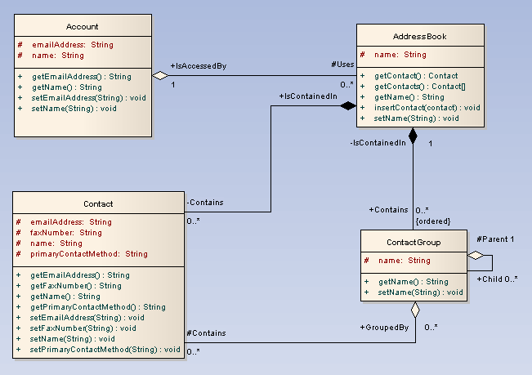

* **Each Account object can be associated to only one AddressBook object.**

False

* **Each contact object must be associated with a ContactGroup object**

True

* **Each ContactGroup object cannot be associated with another contact group object**

True

* **Each AddressBook object must be associated to at least one Contact object.**

False

* **Each ContactGroup object can be associated to more than one AddressBook object**

False

|  |  |  |  |  |  |  |  |
| --- | --- | --- | --- | --- | --- | --- | --- |
|  | 1. **Which of the following are the correct ways to increment the value of variable a by 1?** 2. **++a++;** 3. **a += 1;** 4. **a ++ 1;** 5. **a = a +1;** 6. **a = +1;**  |  | | --- | | 1. **Which of the following is NOT an Arithmetic operator in C#.NET?** 2. **\*\*** 3. **+** 4. **/** 5. **%** 6. **\*** | |  | | 1. **Which of the following is NOT a Bitwise operator in C#.NET?** 2. **&** 3. **|** 4. **<<** 5. **^** 6. **~** | | |  | | --- | | 1. **Which of the following statements is correct about the C#.NET code snippet given below?**   **int d;**  **d = Convert.ToInt32( !(30 < 20) );** | | 1. **A value 0 will be assigned to d.** 2. **A value 1 will be assigned to d.** 3. **A value -1 will be assigned to d.** 4. **The code reports an error. This one** 5. **The code snippet will work correctly if ! is replaced by Not.** 6. **What will be the output of the following code snippet?**   int i = 30;  int j = 5 % 5;  if (Convert.ToBoolean(Convert.ToInt32(i != j)))  {  Console.WriteLine("if Clause executed");  }  else  {  Console.WriteLine("else Clause executed");  }  Console.WriteLine("Entered Main Function");  Console.ReadLine();  **Output:**  **A. if Clause executed B. else Clause executed C.  if Clause executed  Entered Main Function  D. else Clause executed Entered Main Function** | | |

1. **What will be the output of the following code snippet?**

int a, b;

for (a = 2; a >= 0; a--)

{

for (b = 0; b <= 2; b++)

{

if (a == b)

{

Console.WriteLine("1");

}

else

{

Console.WriteLine("0");

}

}

Console.WriteLine("\n");

}

**Output:**

**A. 1 0 0   
0 1 0  
0 0 1  
B. 0 1 0  
1 0 0  
0 0 1  
C.  0 0 1  
0 1 0  
1 0 0  
D. 1 0 0  
0 0 1  
0 1 0**

1. **What will be the output of the following C# code?**
2. **int** i;
3. **for** (i = 0; ; )
4. {
5. Console.WriteLine("hello");
6. }
7. Console.ReadLine();

**a) No output  
b) hello  
c) hello printed infinite times  
d) Code will give error as expression syntax**

1. **What will be the output of the following C# code?**
2. **float** f;
3. **for** (f = 0.1f; f <= 0.5; f += 1)
4. Console.WriteLine( ++f );
5. Console.ReadLine();

**a) 1.1  
b) 0.1  
c) 0.1 0.2 0.3 0.4 0.5  
d) None of the mentioned**

1. **What will be the output of the following C# code?**
2. **int** I, J = 0;
3. **for** (I = 1; I < 10; ) ;
4. {
5. J = J + I;
6. I += 2;
7. }
8. Console.WriteLine("Sum of first 10 even numbers is:"+J);
9. Console.ReadLine();

**a) 1 2 3 4 5 6 7 8 9  
b) 25   
c) 1  
d) Run time error**

1. **Programming Questions (Answer any 4) – (15x4 = 60)**
2. **Given an array of size N containing only 0s, 1s, and 2s; sort the array in ascending order.**

**Input:**

N = 5

arr[]= {0 2 1 2 0}

**Output:**

0 0 1 2 2

1. **Given an unsorted array A of size N that contains only non-negative integers, find a continuous sub-array which adds to a given number S.**

**Example 1:**

**Input:**

N = 5, S = 12

A[] = {1,2,3,7,5}

**Output:** 2 4

**Explanation:** The sum of elements

from 2nd position to 4th position is 12.

**Example 2:**

**Input:**

N = 10, S = 15

A[] = {1,2,3,4,5,6,7,8,9,10}

**Output:** 1 5

**Explanation:** The sum of elements

from 1st position to 5th position

is 15.

1. **Given an array arr[] of N non-negative integers representing the height of blocks. If width of each block is 1, compute how much water can be trapped between the blocks during the rainy season.**

**Example 1:**

Input:

**N = 6**

**arr[] = {3,0,0,2,0,4}**

Output:

**10**

Explanation:

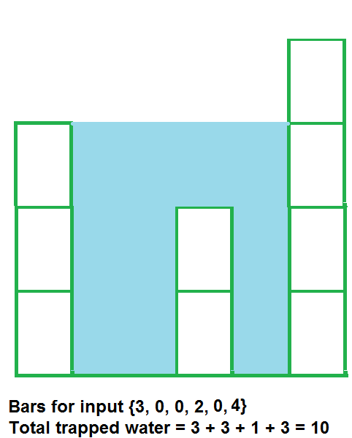

1. **Let the input string be “i like this program very much”. The function should change the string to “much very program this like i”**

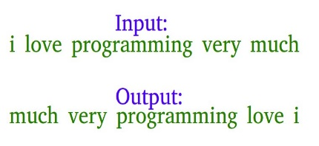

1. **Find whether a string is palindrome or not?**

**Example:** “121” is palindrome as the reverse of the string is “121” which is same

“ABCDFAB” is not palindrome

1. **Given two numbers find the GCF (Greatest Common Factor) and LCM (Lowest Common Multiple) of the two numbers**

**Example:** The GCF and LCM of 3,5 is 1 and 15. The GCF and LCM of 12, 18 is 6 & 36

1. **Design Question (1x5 = 5 marks)**
2. Imagine You oversee a Library system where the students can borrow books and return Books. As well as Librarian needs to have the option to issue book and accept return of books from students.

How would you design such a system? You are expected to create a Class diagram only showing the interactions and not needed to code or show outputs. You can use paint/ Word etc to create the diagram and attach with your answer.